Elastic Search Server

Elastic Search Version 2.4
OS - CentOS7 64 bit
Elasticsearch version 2.4 installation on CentOS 7:

Step 1: Perform the following command to install Java for Elasticsearch
yum install java-1.8.0-openjdk.x86_64

Step 2: Run the following command to import the Elasticsearch public GPG key into rpm:
sudo rpm --import http://packages.elastic.co/GPG-KEY-elasticsearch

Step 4: Perform the following command to create a elasticsearch.repo file to install the elasticsearch.
vi /etc/yum.repos.d/elasticsearch.repo

Add these following contents into the file.
[elasticsearch-2.x]
name=Elasticsearch repository for 2.x packages
baseurl=https://packages.elastic.co/elasticsearch/2.x/centos
gpgcheck=1
gpgkey=https://packages.elastic.co/GPG-KEY-elasticsearch
enabled=1

Please find the following image for reference.

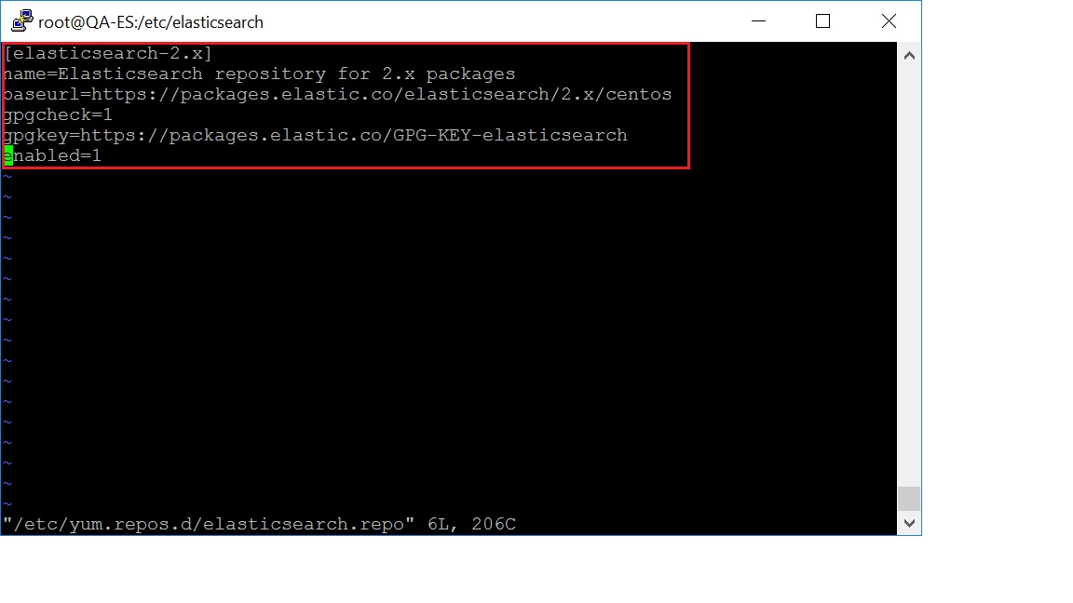

Step 3: Perform the following command to install Elasticsearch:
sudo yum -y install elasticsearch

Step 4: Elasticsearch is now installed. Let's edit the configuration:
sudo vi /etc/elasticsearch/elasticsearch.yml

In that elasticsearch.yml, find the node section and add these following command lines after the 1st line.
script.inline: true
script.indexed: true
script.file: true
script.groovy.sandbox.enabled: true

Please find the following image for reference.

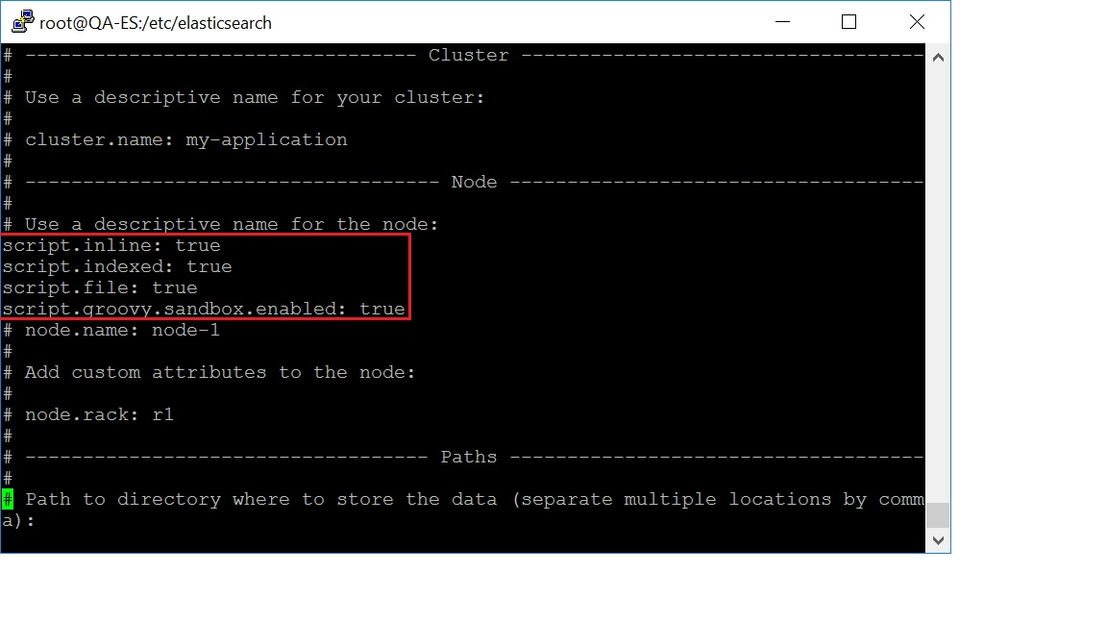

Step 5: And, in the same file, in network section we have to edit the IP address and port number.
network.host: 0.0.0.0
http.port: 9200

Please find the following image for reference.

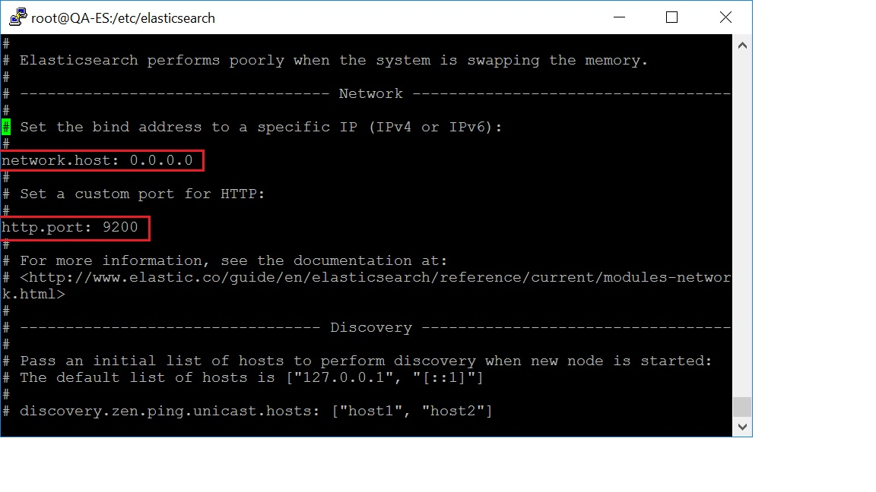After updated the elasticsearch.yml file save and exit.

Step 6: Perform following command Firewall ID installation.
sudo yum install firewalld

Step 7: Perform the following command for adding/enable the elasticsearch port into the firewall.
firewall-cmd --zone=public --add-port=9200/tcp --permanent

Step 8: Perform the following reload command to take the effect applied.
sudo firewall-cmd --reload

Step 9: Perform the following commands to enable automatically start the elasticsearch service while rebooting.
sudo systemctl enable elasticsearch

Step 10: Finally, restart the elasticsearch service by performing the following command
sudo systemctl restart elasticsearch

